|  |
| --- |
| CENTENNIAL COLLEGE |
| External Game Document |
| **Assignment 2 - iOS** |
| Version #02  All work Copyright © 2020 by Veronika Kotckovich & Centennial College.  All rights reserved. |
| **Veronika Kotckovich** |
|  |

|  |
| --- |
| February 16th 2020 |

Table of Contents

Version History 3

Game Description 4

Game Overview 4

Game Play Mechanics 4

Camera 4

Controls 4

Menu and Screen Descriptions 4

Game World 4

Levels 4

Game Progression 4

Characters 5

Non-player Characters 5

Cherries 5

Lives 5

Moon-bullets 5

Enemies 5

Weapons 5

Bonuses 5

Future Features 5

Screen Shots 6

Start Screen 6

Instructions Screen 6

Level 1 7

Level 2 7

Game over screen 8

# Version History

|  |  |  |  |
| --- | --- | --- | --- |
| ID | Date | Author | Changes |
| 1 | Jan 29th | Veronika Kotckovich | Created |
| 2 | Feb 16th | Veronika Kotckovich | Updated |

# Game Description

## Game Overview

*Player should collect as many cherries as possible.*

## Game Play Mechanics

*It’s a platformer game. The player jumps from platform to platform and collects cherries, lives, bullets while avoiding obstacles or killing enemies. When player reaches portals it can go to 2nd level or exit the game .*

## Camera

*Camera follows the player object along X axis.*

## Controls

* Rotate phone left-right in landscape to move the player
* Slide/Swipe on the screen to jump
* Tap on the screen to throw a bullet

## Menu and Screen Descriptions

*One menu screen at the beginning and end of the game, with “Start the game” and “Instructions” button.*

## Game World

*(Describe Your Game Environment)*

## Levels

*2 levels.*

*1st level has only ice obstacles player should avoid.*

*2nd level has also enemies, and player has an ability to throw a bullet to destroy them.*

## Game Progression

*Player collects cherries and avoids enemies and obstacles. When player dies it return to start point of the level.*

## Characters

*Fox – the player, can move freely left-right in the world and jump onto the platforms.*

*Opossums, Eagles - enemies, move left-right a little but around their designated place. Can kill the player. Could be destroyed by moon-bullets.*

## Non-player Characters

Cherries – the score value

Lives – how many attempts player has to pass the levels. Lives amount passes to the 2nd level.

Moon-bullets – Can kill enemies

## Enemies

*Opossums, Eagles - enemies, move left-right a little but around their designated place. Can kill the player. Could be destroyed by moon-bullets.*

## Weapons

Moon-bullets – Can kill enemies. Player has 5 bullets at the beginning of the 2nd level and can collect more on the platforms.

## Bonuses

*Extra lives and moon-bullets*

## Future Features

*More levels*

## Screen Shots

### Start Screen

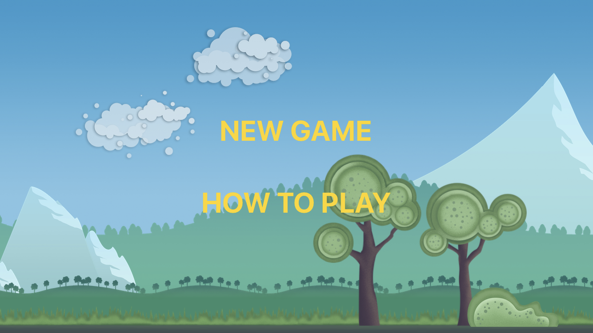

### Instructions Screen

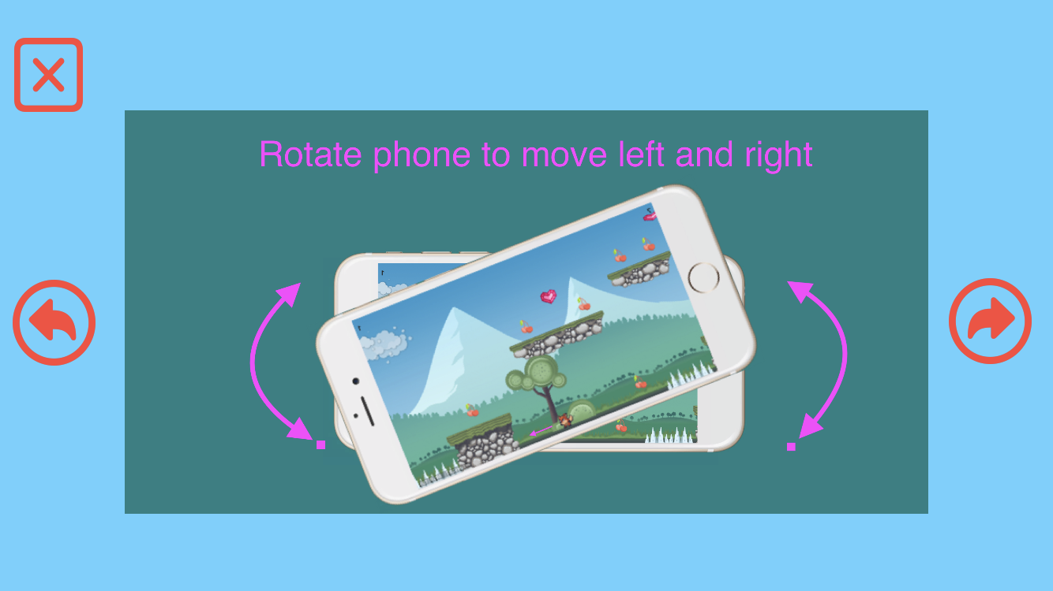

### Level 1

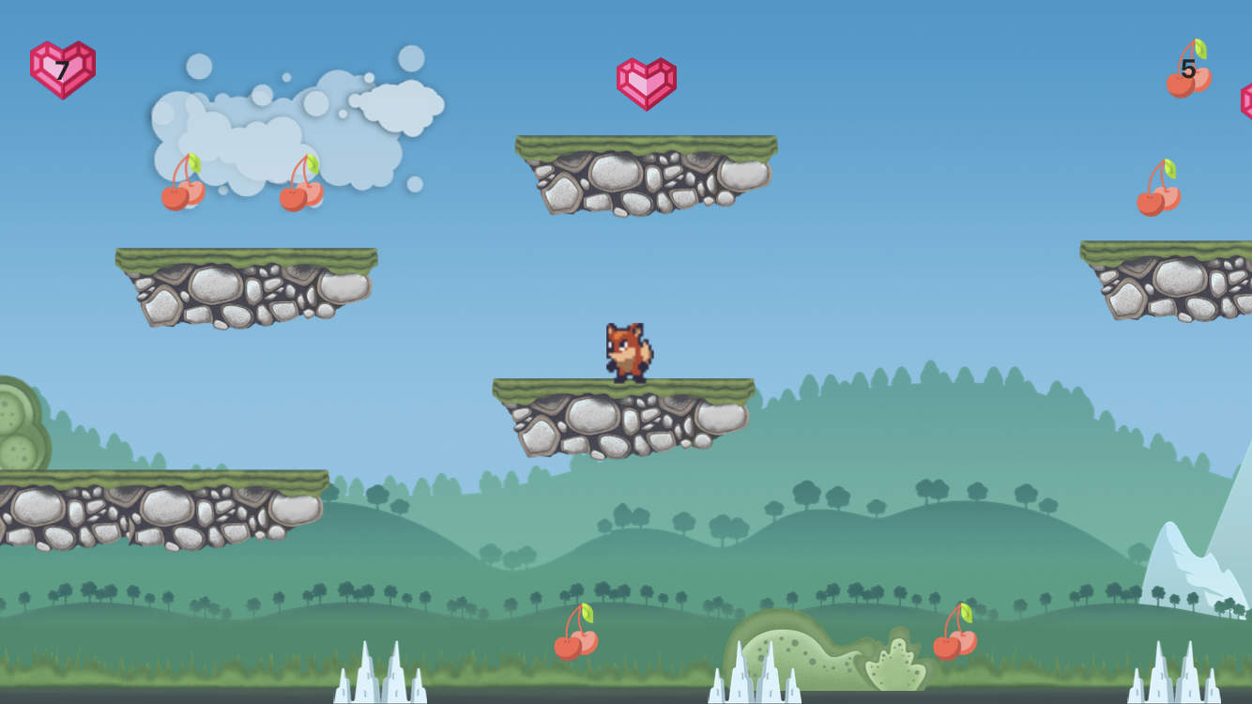

### Level 2

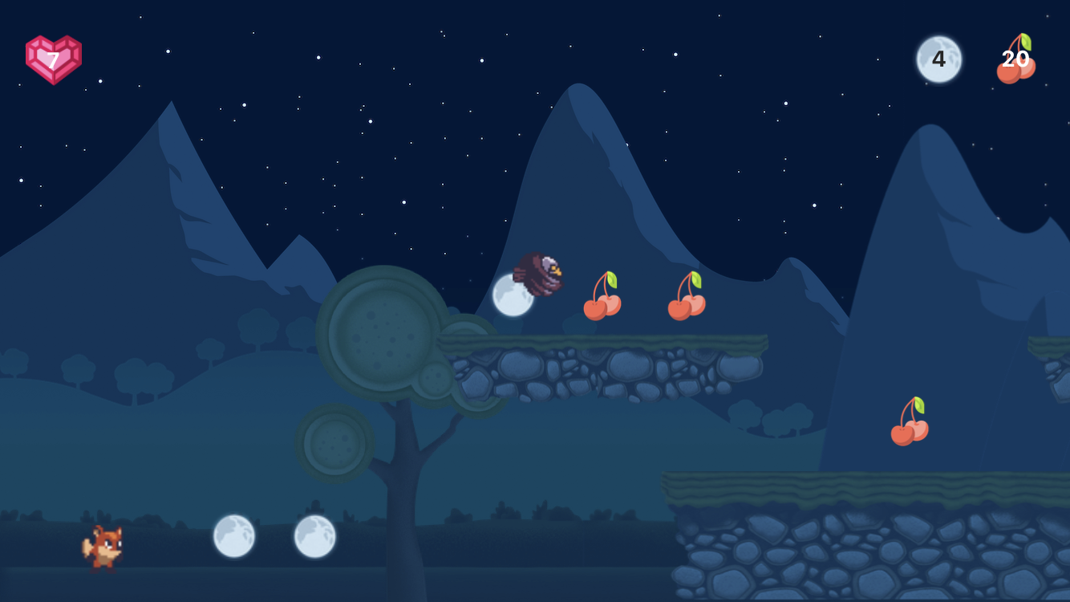

### Game over screen

